**Vehicle Silhouette recognition**

The purpose is to classify a given silhouette as one of four types of vehicle, using a set of features extracted from the silhouette. The vehicle may be viewed from one of many different angles.   
  
HISTORY:   
  
This data was originally gathered at the TI in 1986-87 by JP Siebert. It was partially financed by Barr and Stroud Ltd. The original purpose was to find a method of distinguishing 3D objects within a 2D image by application of an ensemble of shape feature extractors to the 2D silhouettes of the objects. Measures of shape features extracted from example silhouettes of objects to be discriminated were used to generate a classification rule tree by means of computer induction.   
  
This object recognition strategy was successfully used to discriminate between silhouettes of model cars, vans and buses viewed from constrained elevation but all angles of rotation.   
  
The rule tree classification performance compared favourably to MDC (Minimum Distance Classifier) and k-NN (k-Nearest Neighbour) statistical classifiers in terms of both error rate and computational efficiency. An investigation of these rule trees generated by example indicated that the tree structure was heavily influenced by the orientation of the objects, and grouped similar object views into single decisions.   
  
  
DESCRIPTION:   
  
The features were extracted from the silhouettes by the HIPS (Hierarchical Image Processing System) extension BINATTS, which extracts a combination of scale independent features utilising both classical moments based measures such as scaled variance, skewness and kurtosis about the major/minor axes and heuristic measures such as hollows, circularity, rectangularity and compactness.   
  
Four "Corgie" model vehicles were used for the experiment: a double decker bus, Cheverolet van, Saab 9000 and an Opel Manta 400. This particular combination of vehicles was chosen with the expectation that the bus, van and either one of the cars would be readily distinguishable, but it would be more difficult to distinguish between the cars.   
  
The images were acquired by a camera looking downwards at the model vehicle from a fixed angle of elevation (34.2 degrees to the horizontal). The vehicles were placed on a diffuse backlit surface (lightbox). The vehicles were painted matte black to minimise highlights. The images were captured using a CRS4000 framestore connected to a vax 750. All images were captured with a spatial resolution of 128x128 pixels quantised to 64 greylevels. These images were thresholded to produce binary vehicle silhouettes, negated (to comply with the processing requirements of BINATTS) and thereafter subjected to shrink-expand-expand-shrink HIPS modules to remove "salt and pepper" image noise.   
  
The vehicles were rotated and their angle of orientation was measured using a radial graticule beneath the vehicle. 0 and 180 degrees corresponded to "head on" and "rear" views respectively while 90 and 270 corresponded to profiles in opposite directions. Two sets of 60 images, each set covering a full 360 degree rotation, were captured for each vehicle. The vehicle was rotated by a fixed angle between images. These datasets are known as e2 and e3 respectively.   
  
A further two sets of images, e4 and e5, were captured with the camera at elevations of 37.5 degs and 30.8 degs respectively. These sets also contain 60 images per vehicle apart from e4.van which contains only 46 owing to the difficulty of containing the van in the image at some orientations.

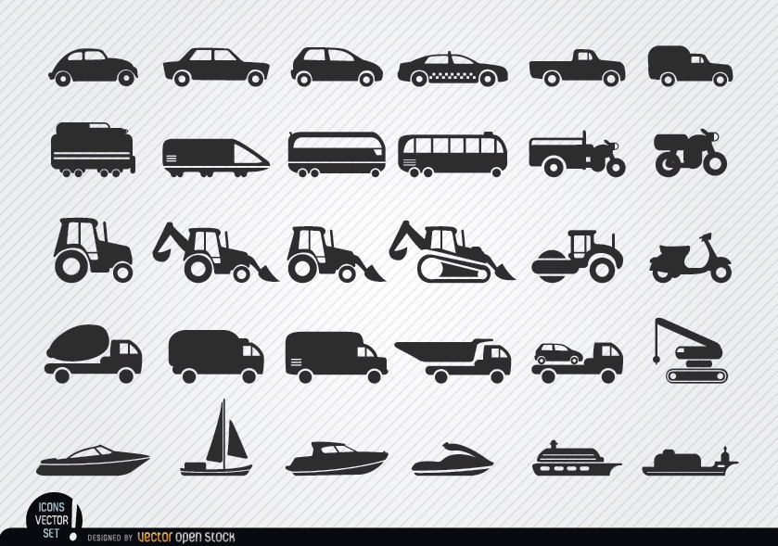

[This Photo](http://vectoropenstock.com/vectors/preview/70425/vehicles-and-ships-silhouettes-icon-set) by Unknown Author is licensed under [CC BY-SA](https://creativecommons.org/licenses/by-sa/3.0/)

**Attribute Information:**

ATTRIBUTES   
  
COMPACTNESS (average perim)**2/area   
  
CIRCULARITY (average radius)**2/area   
  
DISTANCE CIRCULARITY area/(av.distance from border)**2   
  
RADIUS RATIO (max.rad-min.rad)/av.radius   
  
PR.AXIS ASPECT RATIO (minor axis)/(major axis)   
  
MAX.LENGTH ASPECT RATIO (length perp. max length)/(max length)   
  
SCATTER RATIO (inertia about minor axis)/(inertia about major axis)   
  
ELONGATEDNESS area/(shrink width)**2   
  
PR.AXIS RECTANGULARITY area/(pr.axis length*pr.axis width)   
  
MAX.LENGTH RECTANGULARITY area/(max.length*length perp. to this)   
  
SCALED VARIANCE (2nd order moment about minor axis)/area   
ALONG MAJOR AXIS   
  
SCALED VARIANCE (2nd order moment about major axis)/area   
ALONG MINOR AXIS   
  
SCALED RADIUS OF GYRATION (mavar+mivar)/area   
  
SKEWNESS ABOUT (3rd order moment about major axis)/sigma_min**3   
MAJOR AXIS   
  
SKEWNESS ABOUT (3rd order moment about minor axis)/sigma_maj**3   
MINOR AXIS   
  
KURTOSIS ABOUT (4th order moment about major axis)/sigma_min**4   
MINOR AXIS   
  
KURTOSIS ABOUT (4th order moment about minor axis)/sigma_maj**4   
MAJOR AXIS   
  
HOLLOWS RATIO (area of hollows)/(area of bounding polygon)   
  
Where sigma_maj**2 is the variance along the major axis and sigma_min**2 is the variance along the minor axis, and   
  
area of hollows= area of bounding poly-area of object   
  
The area of the bounding polygon is found as a side result of the computation to find the maximum length. Each individual length computation yields a pair of calipers to the object orientated at every 5 degrees. The object is propagated into an image containing the union of these calipers to obtain an image of the bounding polygon.   
  
NUMBER OF CLASSES   
  
4 OPEL, SAAB, BUS, VAN

**Relevant Papers:**

Turing Institute Research Memorandum TIRM-87-018 "Vehicle Recognition Using Rule Based Methods" by Siebert,JP (March 1987)   
[[Web Link]](http://rexa.info/paper/d715d3d76ec59bce66b10e627c2c1aad859f15a7)

Source: <https://archive.ics.uci.edu/ml/datasets/Statlog+(Vehicle+Silhouettes)>